**Name:** Soumyadeep Paul. **Anudip ID:** AF0458093

**University Roll No:** 10900321037

create database sampledemo11;

use sampledemo11;

create table Employee(emp_id int, emp_name varchar(20),emp_sal double);

select * from employee;

insert into employee values(101,'Ramesh Kumar',15000.00);

insert into employee values(102,'Krishna Kumar',20000.00);

delete from employee;

drop table employee;

create table Client_Master(ClientNo varchar(10) primary key,

ClientName varchar(20) not null,

Address1 varchar(20) not null,

Address2 varchar(20),

City varchar(20) not null,

Pincode int not null,

State varchar(20) not null,

Bal double);

select * from Client_Master;

insert into Client_Master values('C001','Vikas kumar','Dadar','Worali',

'Mumbai',111222,'Maharashtra',10000.00);

insert into Client_Master values('C002','Akash Khanna','Dadar','Worali',

'Mumbai',111222,'Maharashtra',10000.00);

select ClientName,City,pincode,State from Client_Master;

alter table Client_Master drop Address2;

alter table Client_Master drop Address1;

alter table Client_Master rename to myclients;

select * from myclients;

truncate table myclients;

drop database sampledemo11;

delete from Client_Master where ClientNo ='C001';

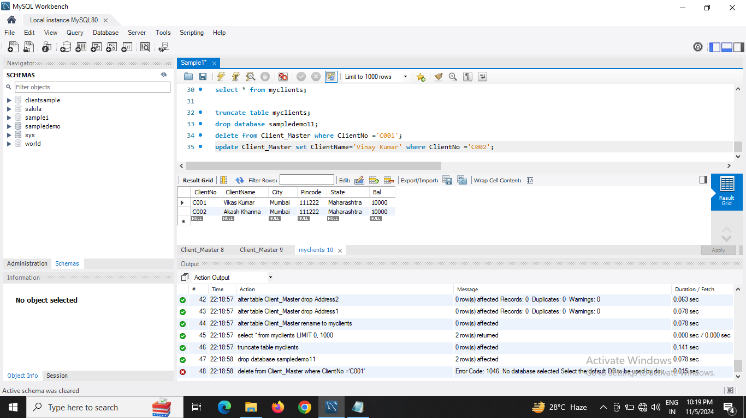update Client_Master set ClientName='Vinay Kumar' where ClientNo ='C002';